**Operating Systems Lab**

**Fall 2024**

**Lab Task 08:**



**Lab Instructor:**

**Kausar Nasreen Khattak**

**Name: Faareha Raza**

**Sap id:47431**

**Email:**

**kausar.nasreen@riphah.edu.pk**

**Lab Task**

**Note:** Include screenshots, required to illustrate your explanation for all Questions.

Q1: Can you provide a detailed guide for each Linux command that includes screenshots and different examples beyond what has been taught? Additionally, can you identify each symbol and explain why it is used? Please explain each step one by one for every command.

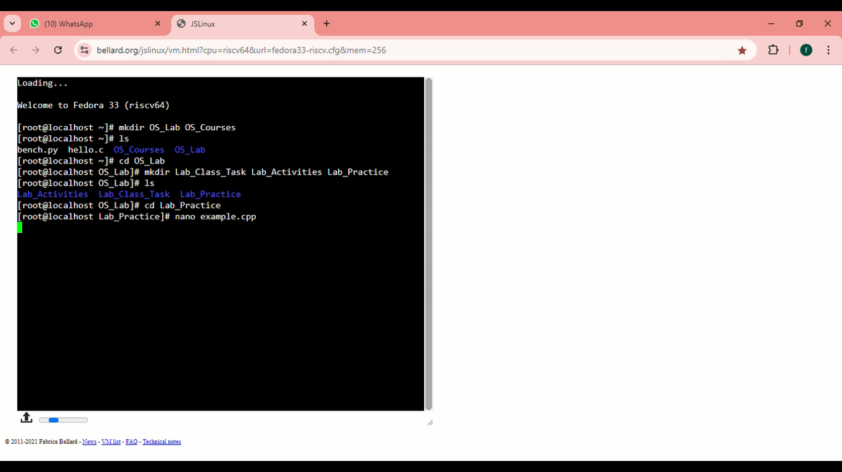

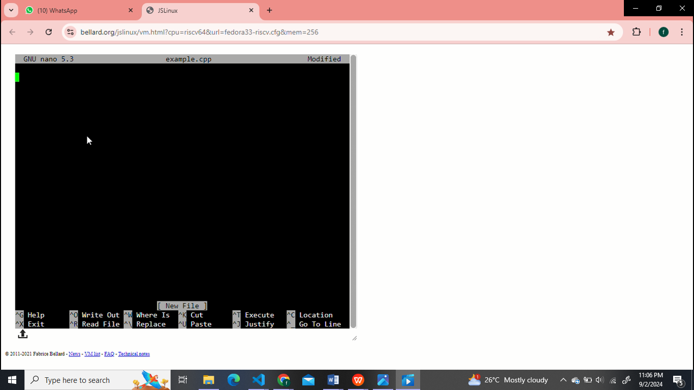

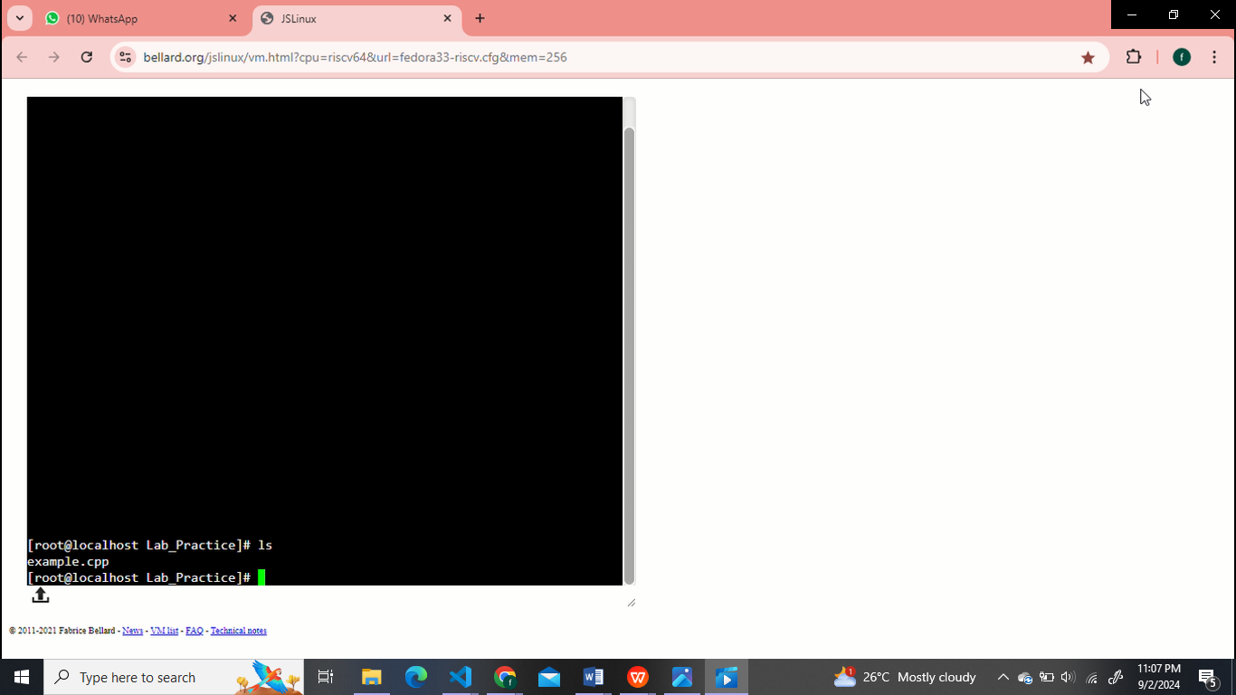

**Relative Path**

It is the path showing where the needed file or folder is situated in relation to the current working directory.

**Example:**

Linux: documents/Faareha.txt if the current directory is /home/user.

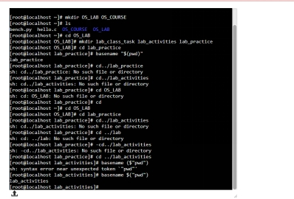

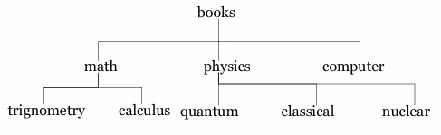

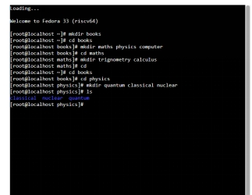

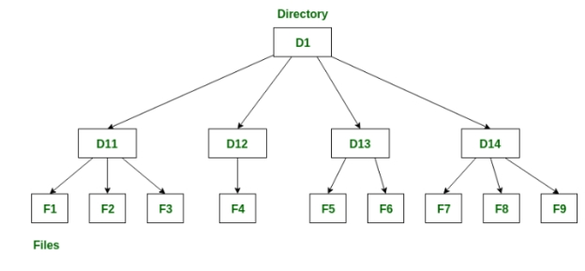

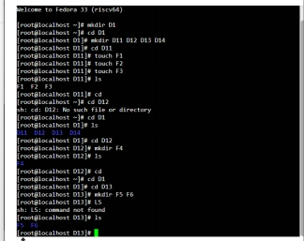

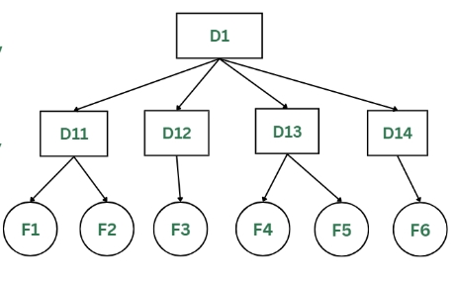

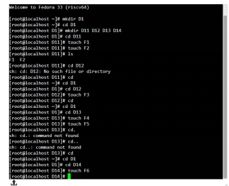

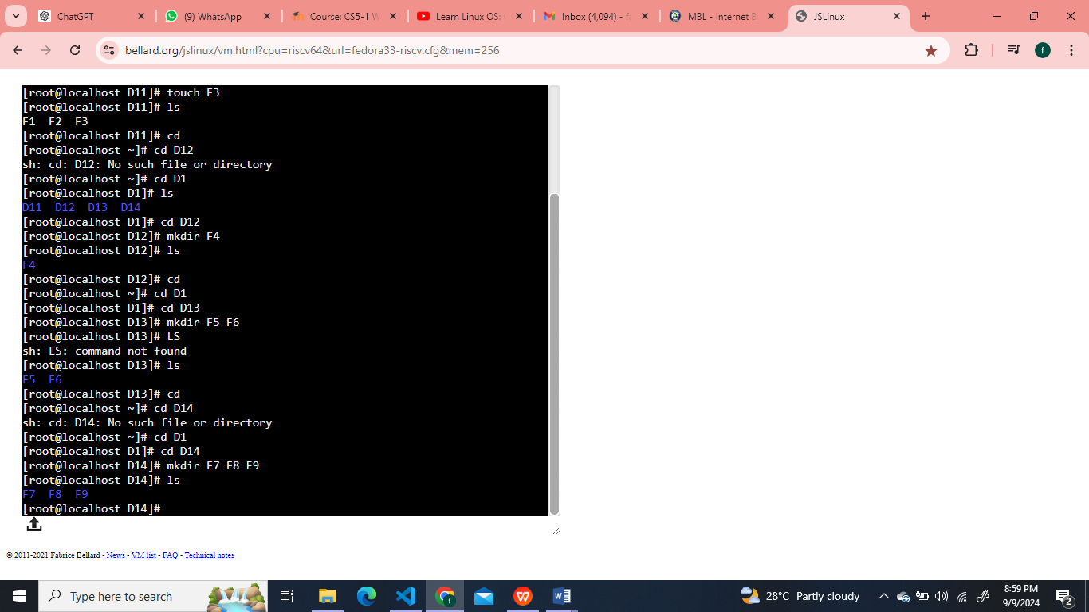

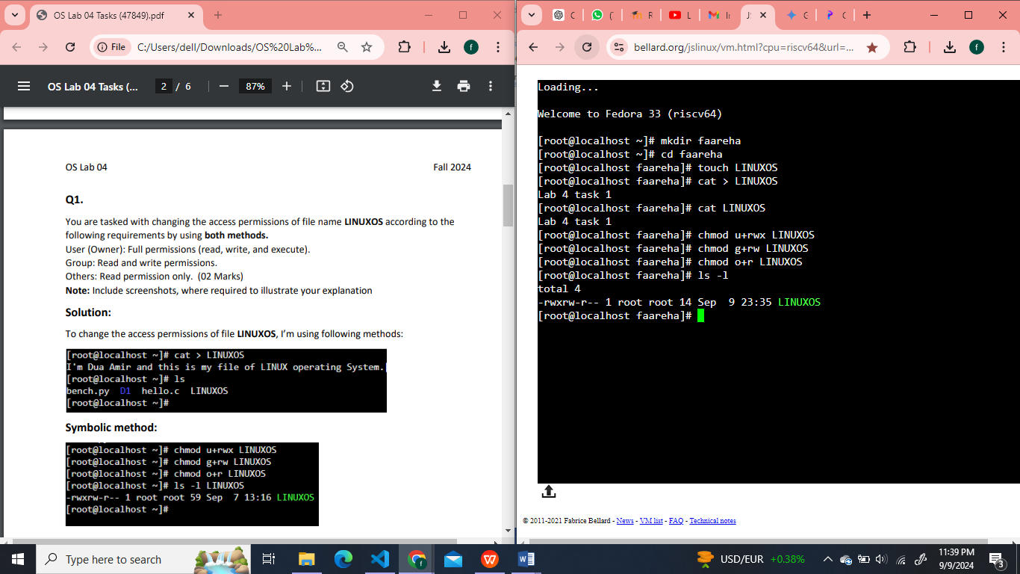

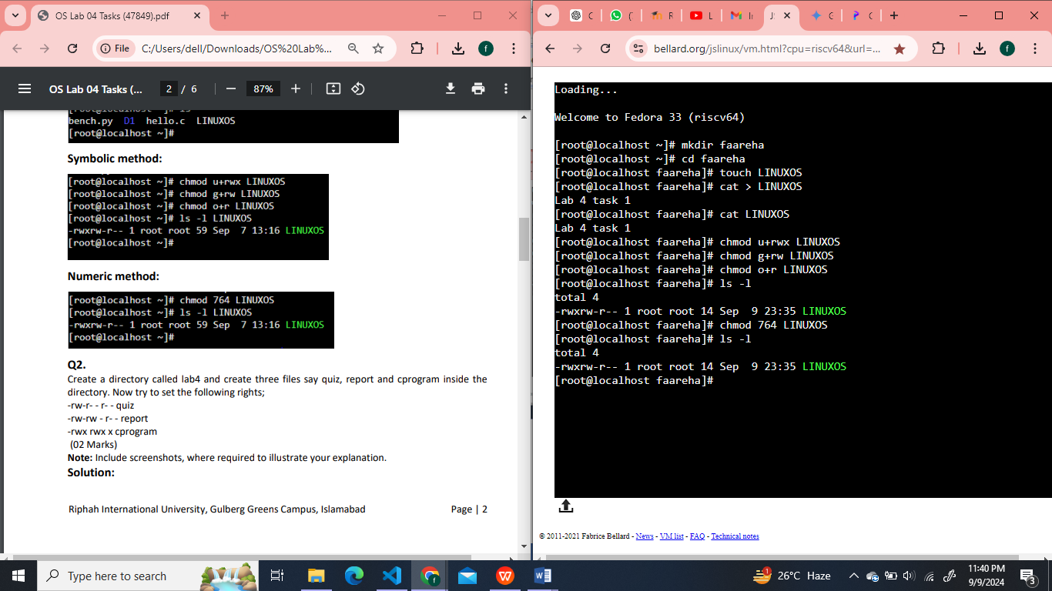

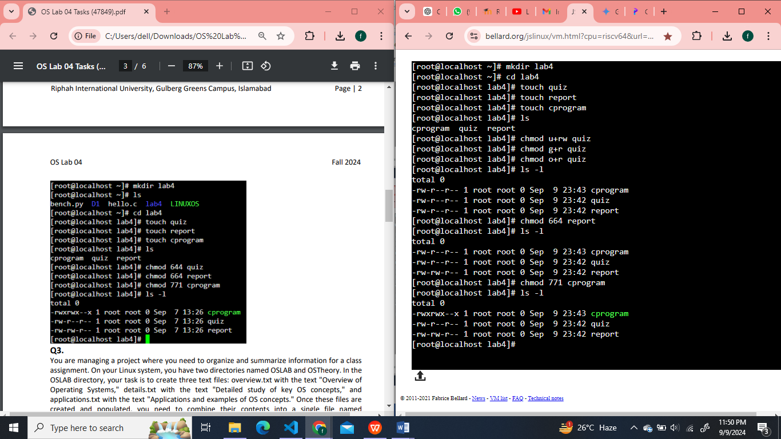

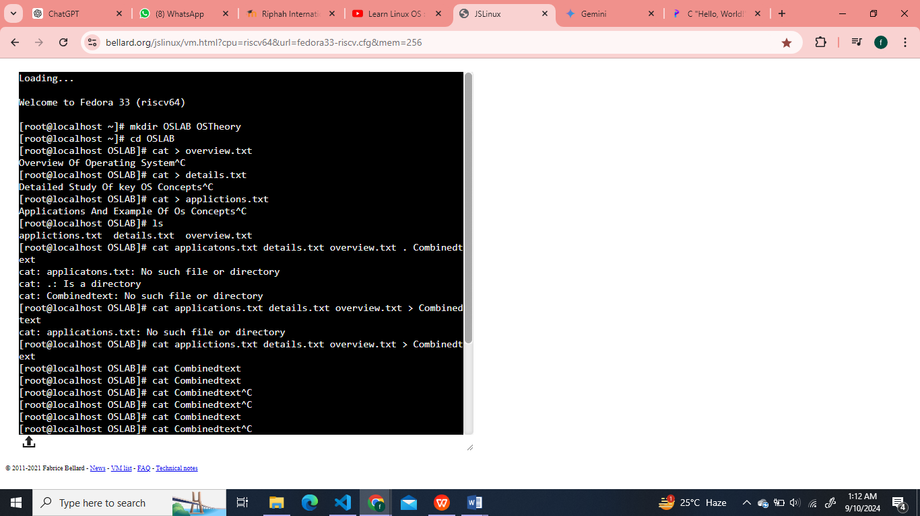

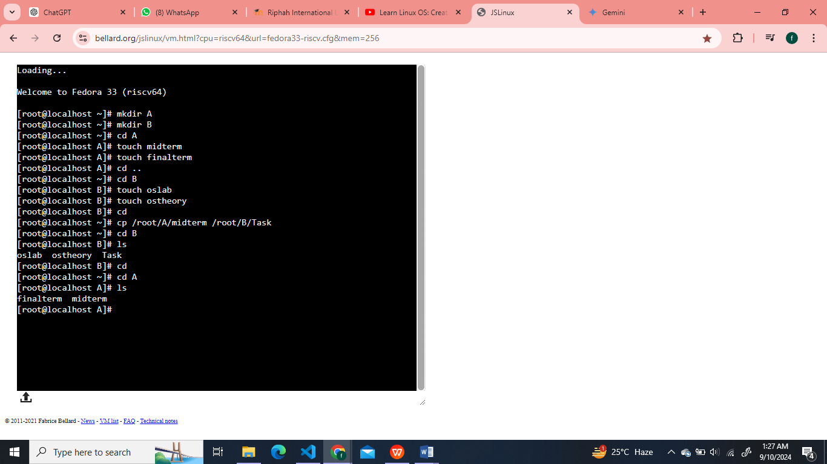

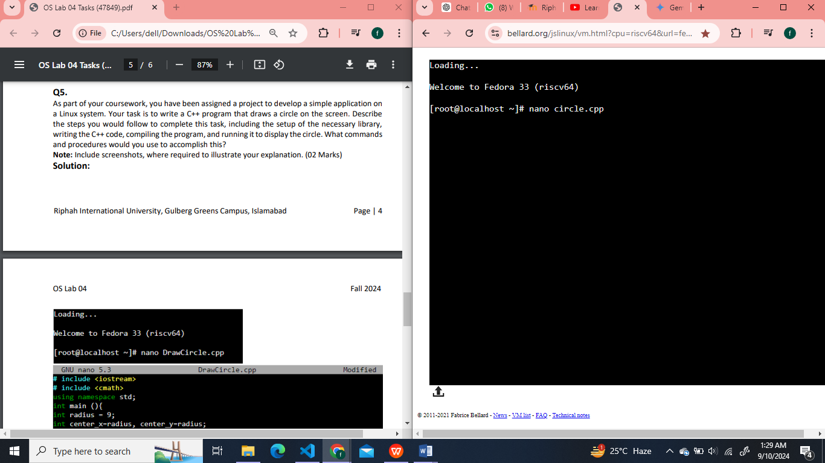

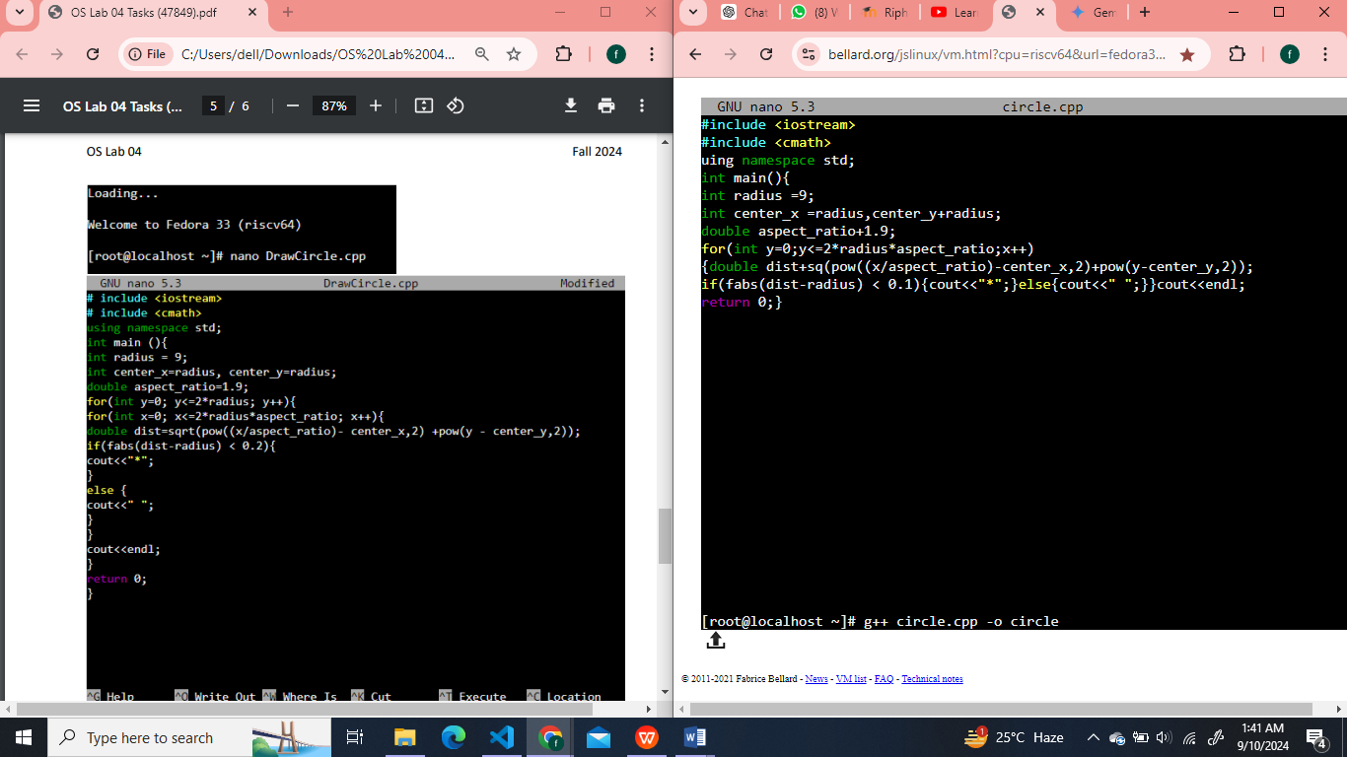

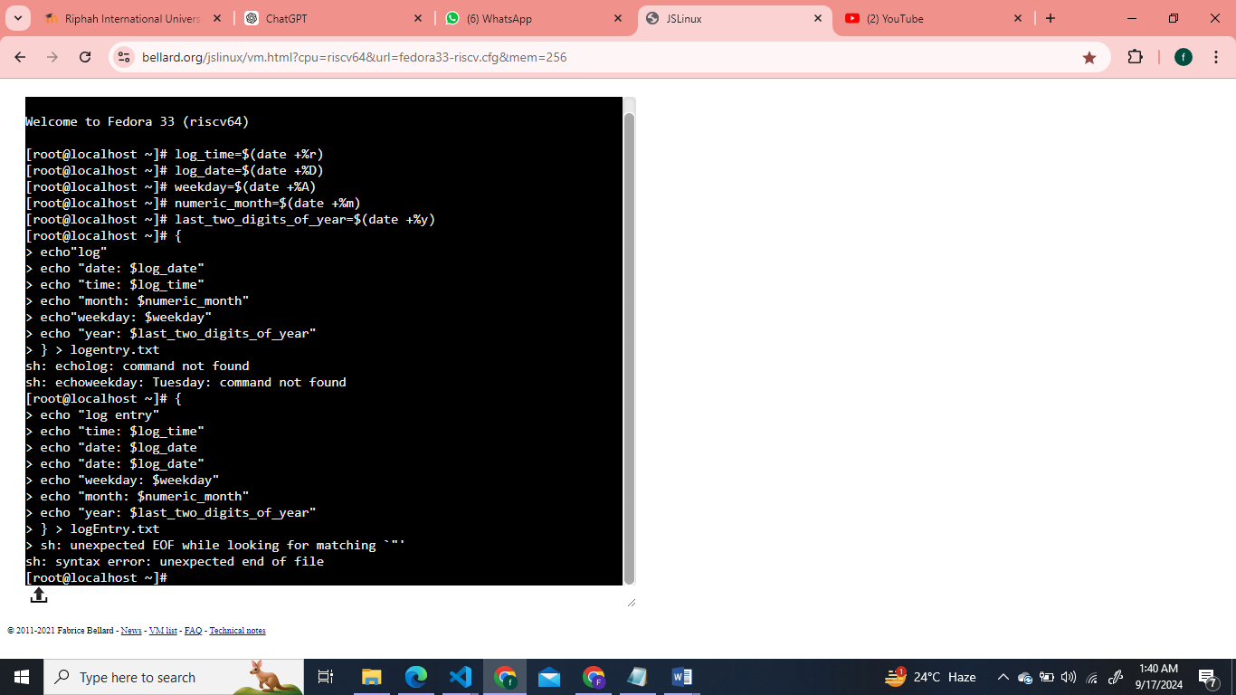

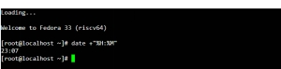

What is the command to get the current year in four-digit format? (0.5 Marks)

C:\Users\dell\AppData\Local\Temp\ksohtml12232\wps9.jpg

How can you get the current date in a combined format of numerical day, month, and year and Time? (0.5 Marks)

C:\Users\dell\AppData\Local\Temp\ksohtml12232\wps10.jpg

You need to determine the date of the previous day from today. Write the command that you would use to get yesterday's date. (0.5 Marks)

C:\Users\dell\AppData\Local\Temp\ksohtml12232\wps11.jpg

You are preparing a schedule and need to find out the date for the following day. What command should you use to display tomorrow's date? (0.5 Marks)

C:\Users\dell\AppData\Local\Temp\ksohtml12232\wps12.jpg

Suppose you are working on a report that needs to include the date exactly 10 days before today. Which command will help you find this date? (0.5 Marks)

C:\Users\dell\AppData\Local\Temp\ksohtml12232\wps13.jpg

You need to quickly view the calendar for the current month to check upcoming events. What is the command to display the calendar for the current month? (0.5 Marks)

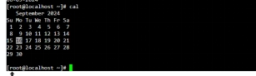

**Y**ou are organizing a historical review and need to view the calendar for May 2024. Write the command that will show the calendar for this specific month and year. (0.5 Marks)

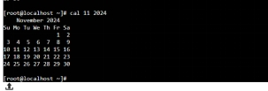

C:\Users\dell\AppData\Local\Temp\ksohtml12232\wps16.jpg

C:\Users\dell\AppData\Local\Temp\ksohtml12232\wps17.jpg

